**Домашняя работа по дискретной математике №5**

**Вариант 1**

Выполнила Абдуллаева София

Исходная таблица соединений R:

## Изоморфизм графов

Матрица смежности G1:

|  |  |  |  |  |  |  |  |  |  |  |  |  |  |
| --- | --- | --- | --- | --- | --- | --- | --- | --- | --- | --- | --- | --- | --- |
| **V/V** | **x1** | **x2** | **x3** | **x4** | **x5** | **x6** | **x7** | **x8** | **x9** | **x10** | **x11** | **x12** | **ri** |
| **x1** | 0 | 1 | 1 | 0 | 0 | 0 | 0 | 1 | 1 | 0 | 0 | 0 | **4** |
| **x2** | 1 | 0 | 0 | 1 | 0 | 1 | 0 | 1 | 1 | 1 | 1 | 0 | **7** |
| **x3** | 1 | 0 | 0 | 0 | 1 | 0 | 1 | 1 | 0 | 1 | 0 | 0 | **5** |
| **x4** | 0 | 1 | 0 | 0 | 0 | 1 | 1 | 1 | 0 | 0 | 0 | 0 | **4** |
| **x5** | 0 | 0 | 1 | 0 | 0 | 0 | 1 | 0 | 0 | 1 | 1 | 0 | **4** |
| **x6** | 0 | 1 | 0 | 1 | 0 | 0 | 0 | 0 | 1 | 1 | 1 | 1 | **6** |
| **x7** | 0 | 0 | 1 | 1 | 1 | 0 | 0 | 1 | 0 | 0 | 1 | 1 | **6** |
| **x8** | 1 | 1 | 1 | 1 | 0 | 0 | 1 | 0 | 1 | 1 | 1 | 1 | **9** |
| **x9** | 1 | 1 | 0 | 0 | 0 | 1 | 0 | 1 | 0 | 1 | 0 | 1 | **6** |
| **x10** | 0 | 1 | 1 | 0 | 1 | 1 | 0 | 1 | 1 | 0 | 0 | 0 | **6** |
| **x11** | 0 | 1 | 0 | 0 | 1 | 1 | 1 | 1 | 0 | 0 | 0 | 1 | **6** |
| **x12** | 0 | 0 | 0 | 0 | 0 | 1 | 1 | 1 | 1 | 0 | 1 | 0 | **5** |

Матрица смежности G2:

|  |  |  |  |  |  |  |  |  |  |  |  |  |  |
| --- | --- | --- | --- | --- | --- | --- | --- | --- | --- | --- | --- | --- | --- |
| **V/V** | **y1** | **y2** | **y3** | **y4** | **y5** | **y6** | **y7** | **y8** | **y9** | **y10** | **y11** | **y12** | **ri** |
| **y1** | 0 | 1 | 0 | 0 | 1 | 1 | 0 | 0 | 0 | 0 | 0 | 1 | **4** |
| **y2** | 1 | 0 | 1 | 1 | 1 | 1 | 0 | 0 | 1 | 0 | 1 | 0 | **7** |
| **y3** | 0 | 1 | 0 | 1 | 0 | 1 | 1 | 0 | 0 | 0 | 0 | 0 | **4** |
| **y4** | 0 | 1 | 1 | 0 | 1 | 0 | 0 | 1 | 1 | 0 | 1 | 0 | **6** |
| **y5** | 1 | 1 | 0 | 1 | 0 | 1 | 0 | 1 | 0 | 0 | 1 | 0 | **6** |
| **y6** | 1 | 1 | 1 | 0 | 1 | 0 | 1 | 1 | 1 | 0 | 1 | 1 | **9** |
| **y7** | 0 | 0 | 1 | 0 | 0 | 1 | 0 | 1 | 1 | 1 | 0 | 1 | **6** |
| **y8** | 0 | 0 | 0 | 1 | 1 | 1 | 1 | 0 | 1 | 0 | 0 | 0 | **5** |
| **y9** | 0 | 1 | 0 | 1 | 0 | 1 | 1 | 1 | 0 | 1 | 0 | 0 | **6** |
| **y10** | 0 | 0 | 0 | 0 | 0 | 0 | 1 | 0 | 1 | 0 | 1 | 1 | **4** |
| **y11** | 0 | 1 | 0 | 1 | 1 | 1 | 0 | 0 | 0 | 1 | 0 | 1 | **6** |
| **y12** | 1 | 0 | 0 | 0 | 0 | 1 | 1 | 0 | 0 | 1 | 1 | 0 | **5** |

Для графа G1 Σρ(x)=68. Список Ρ(x) = {4, 7, 5, 4, 4, 6, 6, 9, 6, 6, 6, 5}

Для графа G2 Σρ(y)=68. Список Ρ(y) = {4, 7, 4, 6, 6, 9, 6, 5, 6, 4, 6, 5}

Разобьем вершины обоих графов на классы по их степеням.

|  |  |  |  |  |  |
| --- | --- | --- | --- | --- | --- |
|  | P(x) = P(y) = 9 | P(x) = P(y) = 7 | P(x) = P(y) = 6 | P(x) = P(y) = 5 | P(x) = P(y) = 4 |
| x | x8 | x2 | x6, x7, x9, x10, x11 | x3, x12 | x1, x4, x5 |
| y | y6 | y2 | y4, y5, y7, y9, y11 | y8, y12 | y1, y3, y10 |

Из таблицы сразу можно заметить соответствие вершин графов:

|  |  |
| --- | --- |
| X | Y |
| x8 | y6 |
| x2 | y2 |

Для определения соответствия вершин с P(x)=P(y)=6 попробуем связать вершины P(x)=P(y)=4 и P(x)=P(y)=5 с неустановленными вершинами

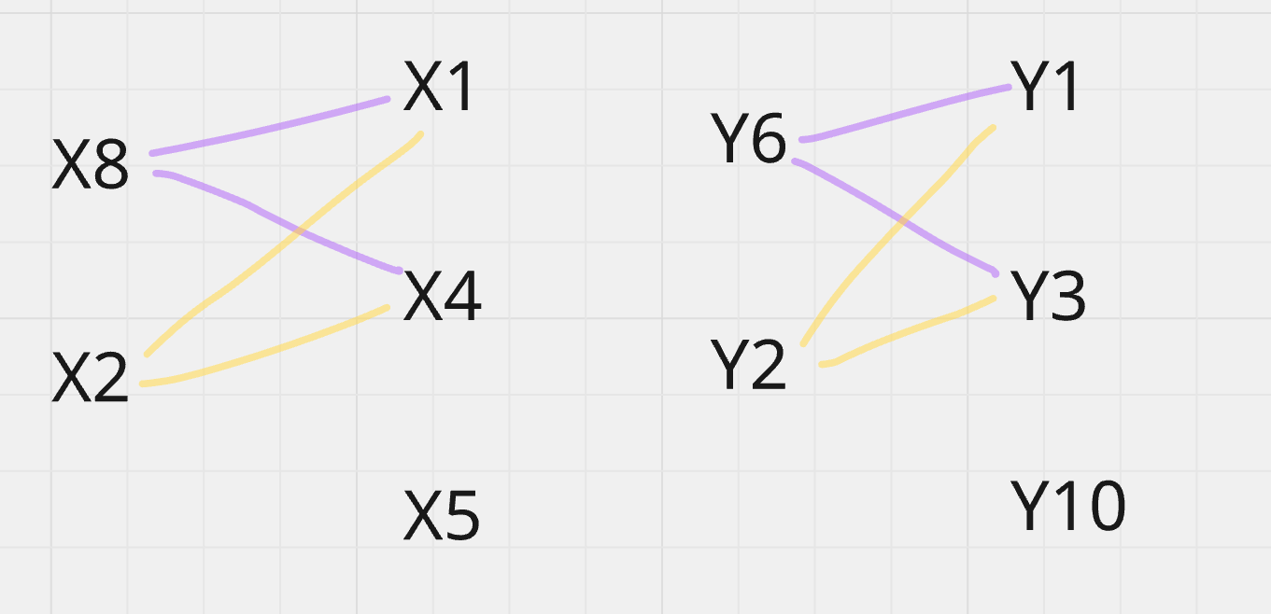

Видно, что друг другу соответствуют вершины x1-y1, x4-y3, x5-y10

Тогда вот следующие соответствия:

|  |  |
| --- | --- |
| X | Y |
| x1 | y1 |
| x4 | y3 |
| x5 | y10 |
| x2 | y2 |
| x8 | y6 |

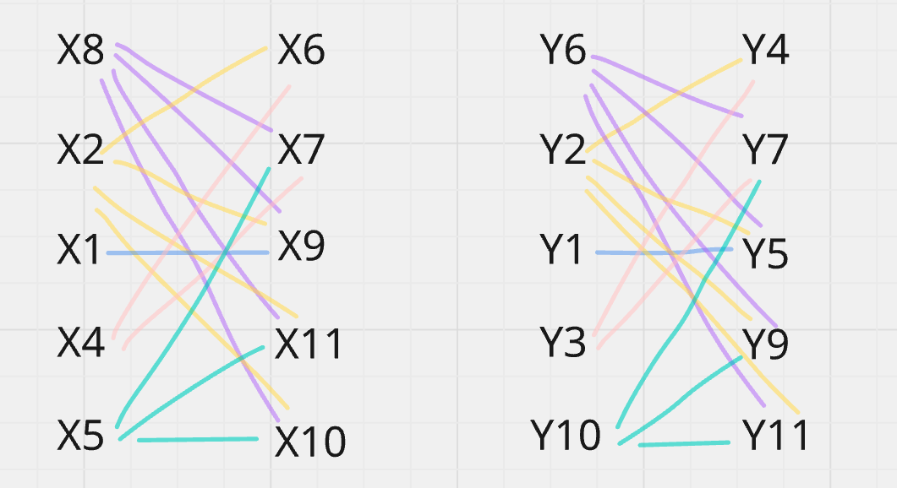

Видно, что друг другу соответствуют вершины x6-y4, x7-y7, x9-y5, x11-y9, x10-y11

|  |  |
| --- | --- |
| X | Y |
| x1 | y1 |
| x4 | y3 |
| x5 | y10 |
| x2 | y2 |
| x8 | y6 |
| x6 | y4 |
| x7 | y7 |
| x9 | y5 |
| x10 | y11 |
| x11 | y9 |

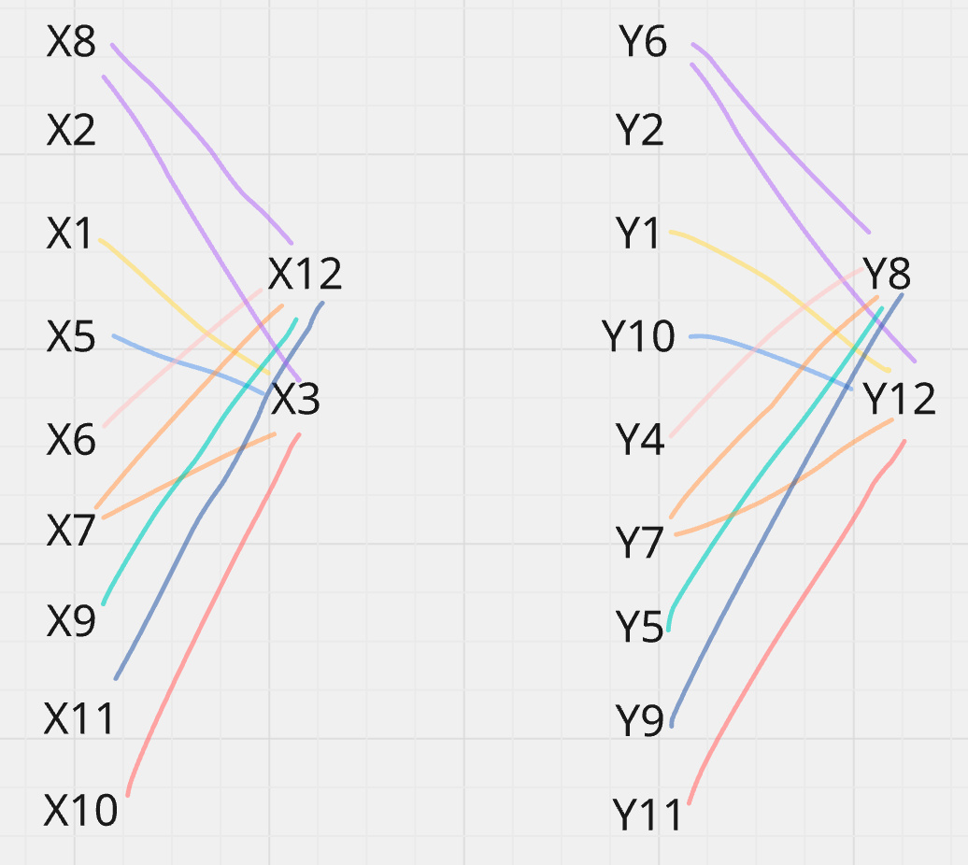

Видно, что друг другу соответствуют вершины x12-y8, x3-y12

|  |  |
| --- | --- |
| X | Y |
| x1 | y1 |
| x4 | y3 |
| x5 | y10 |
| x2 | y2 |
| x8 | y6 |
| x6 | y4 |
| x7 | y7 |
| x9 | y5 |
| x10 | y11 |
| x11 | y9 |
| x12 | y8 |
| x3 | y12 |

Все вершины имеют связь. Следовательно, графы G1 и G2 изоморфны